1. Control Flow Diagram

The data science stage, which employs analytics for project planning, procedures, and market trend monitoring, necessitates the usage of the flowcharts. For the project development and evaluation. By ensuring that the project is to the stakeholder and that of the data pipeline and data gathering of actionable insights are easy to understand, a well-structured flowchart also encourages transparency of the efficient project execution. IBM (2022) claims that the use of visual aids such as flowcharts in the data science initiatives improves the cooperation of specialists and technical teams.

The logical steps or phases that make up of the system or process are depicted in a control flowchart (CFD). Input and output are represented by parallelograms, to the decision points by diamonds, activities or processes by rectangles, beginning and ending points by circles, and branching or convergence by connections. By following the process through to the end of the stakeholders can understand the sequential sequence of events, including the decision-making points when the process due to deviates due to specific circumstances.

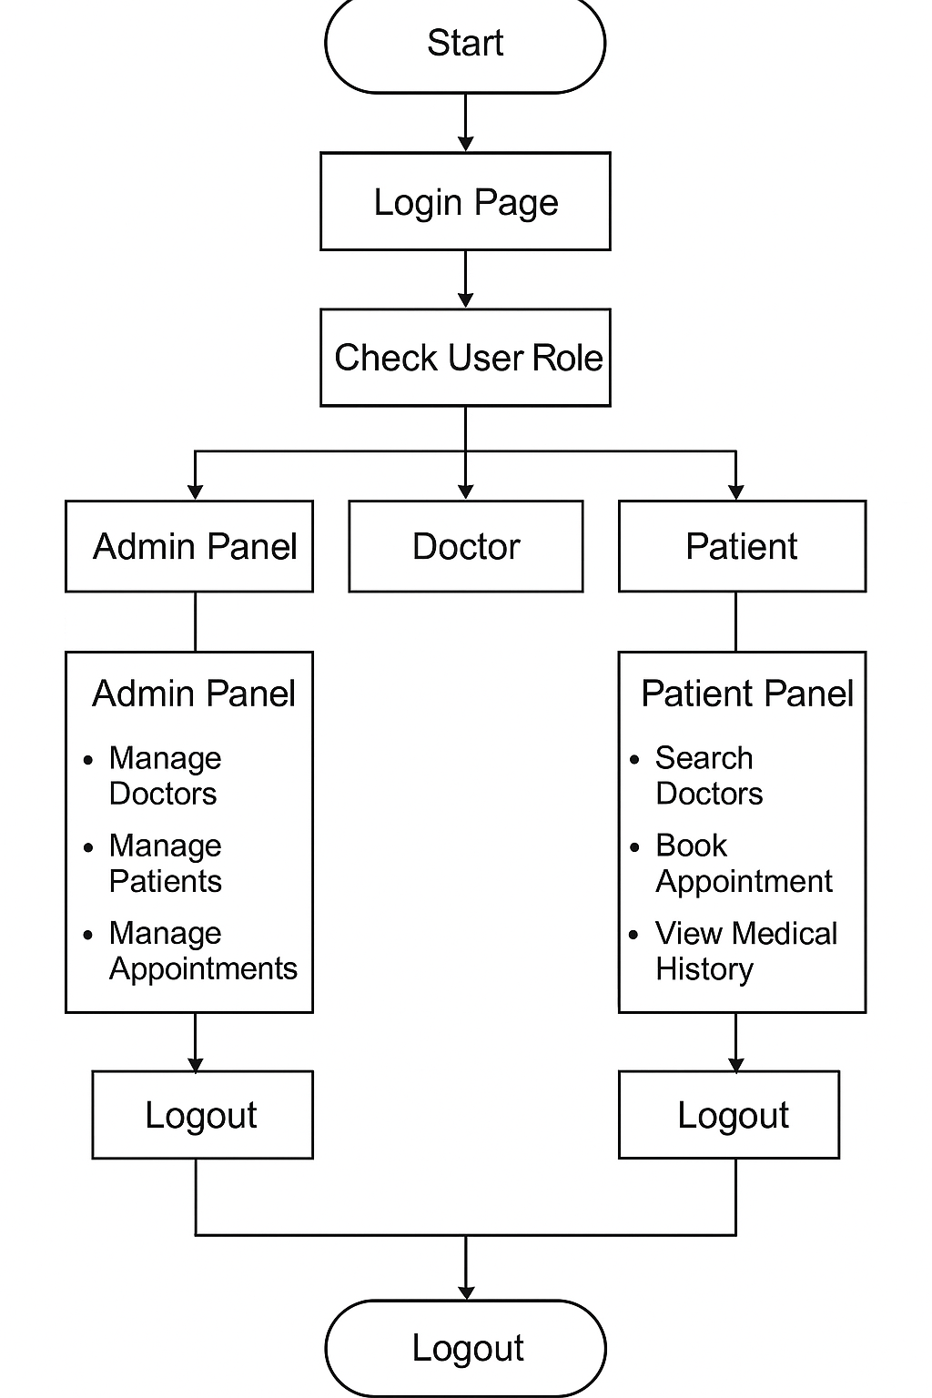

Fig: -The Flowchart for Healthcare

Fig: - The flowchart of the web application